Bike Encounters - Erasmus Sport
B2 - Collection of good practices

Good practices Template
Title Trail Road EuroVelo R10 seaside Hanse around Baltic
Short Description
European network of cycling trails. It is a project of the European Cyclists' Federation, whose goal is to build fourteen long-distance bicycle routes across Europe. The total length of the routes is expected to be over 70,000 km. These trails are for bicycle touring across the continent; They are built based on the existing network of local, regional and national cycle routes and paths, combining them into one system. EuroVelo is co-financed by the European Union. International circular cycle route network EuroVelo running around the Baltic Sea with a total length of 8539 km. Polish section of the trail with a length of 588 km runs through the areas Zachodniopomorskie, Pomerania and Warmia-Mazury.
How the practice is Realized - the methodology
Route are:
Episode Polish: Swinoujscie - Miedzyzdroje - Dziwnow - Rewal - Kolobrzeg - Mielno - Darłowo - Jarosławiec - Ustka - Leba - Wladyslawowo - Puck - Błądzikowo - Rzucewo - Gdynia - Sopot - Gdańsk - Elblag - Frombork - Braniewo - Gronowo
Episode international: Kaliningrad - Klaipeda - Liepaja - Riga - Saaremaa - Tallinn - Narva - St. Petersburg - Helsinki - Turku - Oulu - Sundsvall - Stockholm - Gotland - Kalmar - Ystad - Bornholm - Malmo - Copenhagen - Odense - Kiel - Rügen - Rostock - Ahlbeck (Heringsdorf)
The best prepared and most diverse in terms of sightseeing is a section of the trail runs along the German coast of the Baltic Sea.

Why - Objectives - motivations
A characteristic feature of the route of EuroVelo is to ensure safe driving conditions and comfort of the rider. Good marking routes or functional parking space is a showcase of these routes. Surface routes is the main road, built of concrete blocks or mineral surface, remains a part of the track gravel. With 80 routes capable of staging points to where you can relax or take refuge in case of unfavorable weather.
The project is focused on the promotion, development and Commercialization of the bicycle tourism product in the South Baltic countries based on the EuroVelo 10 route, using the natural and cultural tourism resources of the regions covered by the program.

Individual tasks in the project are Implemented as part of the assumed work packages, the most important concern of Which WP1 Management and Coordination; WP2 Communication and dissemination; WP3 Strategy, research, database; WP4 Cooperation network, online tools; WP5 promotional activities; WP6 - innovative pilot investments. The Pomeranian Tourist Board as the Lead Partner of the project coordinates the implementation directory of all tasks, with a Particular emphasis WP1, WP2 and WP5.
The main elements of the project include:
- Quantitative and qualitative research of cycle tourists on the EV10 route
- Establishment of a coherent and uniform information base on cycling tourism in the regions covered by the project along the EV10 route
- Development of a uniform information system regarding to the route
- Development of a long-term strategy for the development of the further Top EV10 covering the South Baltic area
- Training the workforce of informants and Establishing a lasting cooperation between the tourist information centers, situated along the EV10 route, in order to provide your proper information about the route
- Establishment of a network of business partners creating an offer for bicycle tourists along the route (travel agencies, carriers ferry, accommodation facilities, etc.)
- Preparation of promotional tools and Implementation of an information and promotion campaign about the route using marketing tools, dedicated a key target groups and opinion leaders.
The planned result of the project is the Increased popularity, Attractiveness and visibility of the seaside tourist attractions of the South Baltic area, connected, promoted and integrated as a common, cross-border, sustainable, active tourism product - the cycle route of the Baltic Sea section on the Copenhagen-Gdańsk.
Where - places of the activities
Selected places and attractions of the route:

With Whom - beneficiaries, and all actors Involved
Lead partner: Pomeranian Tourist Board, Gdańsk, Poland
Self-government of the Pomorskie Voivodship, Gdańsk, Poland
Self-government of the Western Pomeranian Voivodship, Szczecin, Poland
European Cyclists' Federation, Brussels, Belgium
Mecklemburg - Vorpommern Tourist Board, Rostock, Germany
Center for Regional and Tourism Research, Nexo, Borholm, Denmark
Danish Cycling Tourism, Copenhagen, Denmark
The project is co-financed by the European Regional Development Fund under the Interreg VA Poland - Denmark - Germany - Lithuania - Sweden (South Baltic) 2014 -2020.
Timing
The tour is available year-round. Currently, the Polish section of the trail being developed within the Interreg project "South Baltic Biking" aimed at upgrading existing routes and certification standards EuroVelo. Investments are to be completed by 2020.
The "South Baltic Biking! Promotion and development of the Baltic Sea Cycle Route (Route No. 10) in Denmark, Germany, Lithuania, Poland and Sweden "project is Implemented with funds from the European Regional Development Fund under the Interreg VA Poland - Denmark - Germany - Lithuania - Sweden (South Baltic) 2014 -2020 program.
References
https://pl.wikipedia.org/wiki/Szlak_rowerowy_R10; https://pomorskie.eu/-/pomorskie-trasy-rowerowe-fantastyczne-widoki-i-miejsce-w-ktorym-naprawisz-rower-i-odpoczniesz; https://www.prot.gda.pl/biking-south-baltic/
Photos-Videos

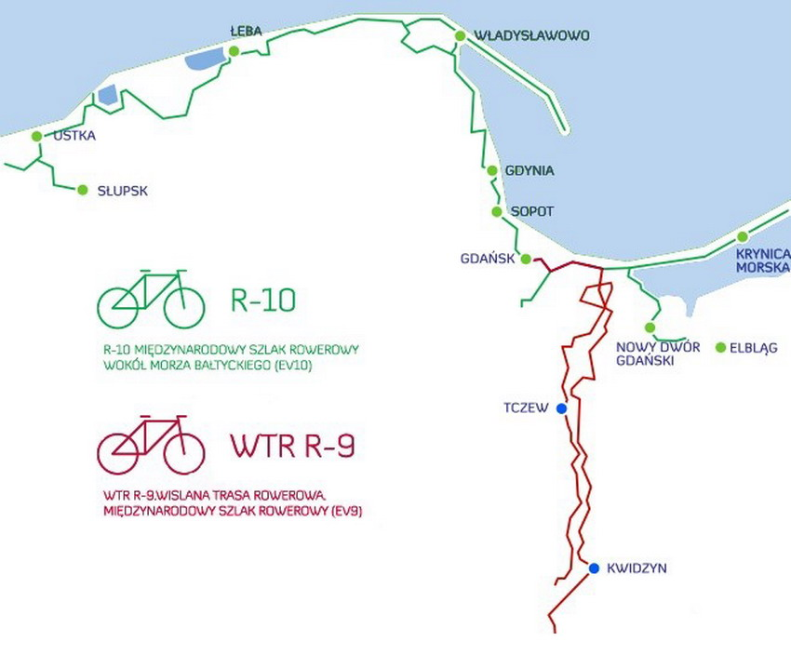
https://www.youtube.com/watch?v=osjGJrUQ7S4
Authors
Olga Smoleńska, Kazimierz Waluch (IRSiE)

